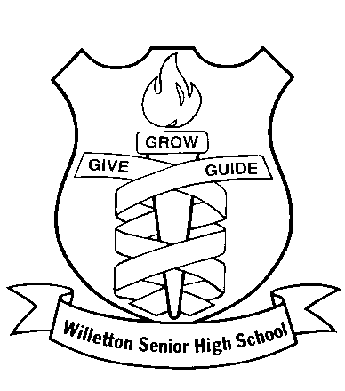**CHEMISTRY 12 ATCHE**

**2021 Organic Chemistry TEST ANSWER SHEET**

**Recommended time: 55 minutes**

**Total marks**

**/ 52**

Name: _____________________________________________________

Teacher: _____________________________________________________

This test is in two parts.

**Part 1:** Multiple choice style consisting of (10) questions.

Each question is worth 1 mark.

Write your answers in the multiple choice answer sheet provided.

Attempt ALL Questions

**Part 2:** Short questions and an extended answer question worth 45 marks.

Write all answers in the spaces provided.

The marks allocated to each question are shown next to each question.

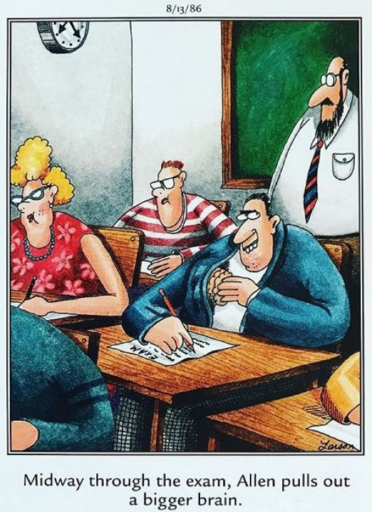

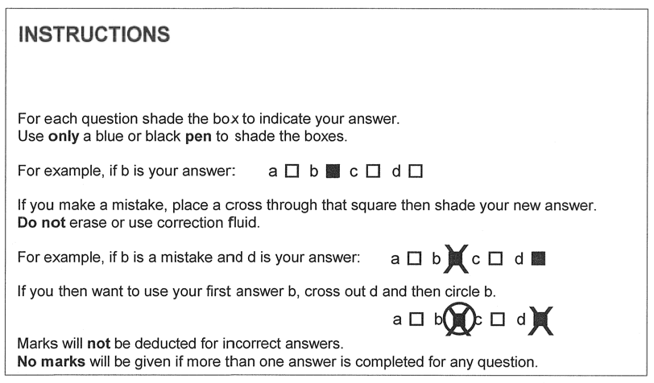

|  |  |  |  |  |
| --- | --- | --- | --- | --- |
| 1. | a 🞏 | b 🞏 | c 🞏 | d 🞏 |
| 2. | a 🞏 | b 🞏 | c 🞏 | d 🞏 |
| 3. | a 🞏 | b 🞏 | c 🞏 | d 🞏 |
| 4. | a 🞏 | b 🞏 | c 🞏 | d 🞏 |
| 5. | a 🞏 | b 🞏 | c 🞏 | d 🞏 |
| 6. | a 🞏 | b 🞏 | c 🞏 | d 🞏 |
| 7. | a 🞏 | b 🞏 | c 🞏 | d 🞏 |
| 8. | a 🞏 | b 🞏 | c 🞏 | d 🞏 |
| 9. | a 🞏 | b 🞏 | c 🞏 | d 🞏 |
| 10. | a 🞏 | b 🞏 | c 🞏 | d 🞏 |

/10

**PART ONE: MULTIPLE CHOICE QUESTIONS (10 marks)**

1. Consider the molecule aspartame, shown below.  
     
     
     
     
   Which of the following functional groups is **not** present in aspartame?
2. amine
3. alcohol
4. amide
5. ester
6. Which of the following molecules would have the most structural isomers?
7. propane
8. 2-methylpropane
9. butane
10. 2-methylbutane
11. Which of the following molecules could have a geometric isomer?
12. 1,1-chloro-prop-1-ene
13. 1,2-dichloroprop-1-ene
14. but-1-ene
15. 2-chlorobut-1-ene
16. Which of the following is the correct IUPAC name for the molecule shown below?  
      
    
17. 1,1-dimethyl propanoic acid
18. 2-methyl butanoic acid
19. 3-methyl butanoic acid
20. 2-ethyl propanoic acid
21. Which of the following condensed formula is paired with its correct IUPAC name?

|  |  |  |
| --- | --- | --- |
|  | CH3CCH3ClCH3 | 2-chloro-2-methylpropane |
|  | CH3(CH2)5CH2OH | Octan-1-ol |
|  | (CH3)2CH(OH) | Propanol |
|  | (CH3)2CO | Propanal |

1. The molecule represented by the structural formula below is the alarm pheromone produced by honey bees:



This molecule could be classified as:

1. an alkane.
2. a ketone.
3. an ester.
4. a carboxylic acid.

1. Which of the following substances would you expect to have the highest boiling point?
2. ethanoic acid
3. methanoic acid
4. ethanal
5. ethanol
6. If methanol is treated with potassium dichromate, K**2**Cr**2**O**7**, the green chromium ion, Cr**3+**, is formed along with:
7. methanone.
8. methanoic acid
9. methyl methanoate.
10. potassium methanoate.
11. When a purple solution is added to an organic liquid, a pale pink solution is formed. After the reaction has completed, when the solution produced from the above reaction is distilled, the boiling point of one of its components is found to be lower than that of the original organic liquid.

The original organic liquid could be a

1. Primary alcohol
2. Secondary alcohol
3. Ketone
4. Aldehyde
5. Which of the following substances could not be produced by the reaction of a carboxylic acid with an amine?
6. A salt
7. A positive ion
8. An amine
9. water

**PART TWO: SHORT ANSWER QUESTIONS (44 marks)**

**Question 11 (3 marks)**

Complete the following table showing the structure and names of three organic compounds.

|  |  |
| --- | --- |
| **Structure** | **IUPAC Name** |
|  |  |
|  |  |
|  | 2-methylpentan-3-one |

**Question 12 (6 marks)**

Complete the table by drawing the structure and giving the IUPAC name of the organic compounds that match each of the following descriptions.

|  |  |  |
| --- | --- | --- |
| **Description** | **Structure** | **IUPAC name** |
| A saturated tertiary alcohol containing 12 hydrogen atoms |  |  |
| An ester that is an isomer of hexanoic acid and made from ethanol |  |  |
| A hydrocarbon that could be used to make 1,2-difluoro-3-methylbutane via an addition reaction |  |  |

**Question 13 (10 marks)**

A sample weighing 0.271g of a non-cyclic organic substance was burnt in a combustion chamber. Water (0.269g) and carbon dioxide ( 0.662g ) were the only products formed. The chemist knew from its reaction with potassium permanganate, and its lack of reaction with bromine water, that the substance must either be an alcohol or an aldehyde, and therefore must contain oxygen. Use this information to calculate the compounds empirical formula. (8 marks)

Was the compound an aldehyde, or an alcohol? Give a reason for your answer. (2 marks)

|  |
| --- |
|  |

**Question 14 (8 marks)**

The following synthetic pathway shows the formation of ethyl ethanoate from ethene.



Write out the reactions in equation form, making sure to show any reactants or products not mentioned in this synthesis diagram. (you may use molecular, full or condensed formula at your preference) (6 marks)

|  |
| --- |
| a. |

|  |
| --- |
| b. |

|  |
| --- |
| c. |

|  |
| --- |
| Space for working: |

d.) Give three (3) considerations that chemists must take into account when deciding a synthesis pathway for a chemical. (2 marks)

|  |
| --- |
|  |
|  |

**Question 15 (3 marks)**

Complete the following table. Make sure that you use square brackets to indicate that the structure you have drawn is a polymer.

|  |  |
| --- | --- |
| Polymer | Monomer(s) structure |
|  |  |
|  | and |
|  |  |

**Question 16 (3 marks)**

Describe, with the use of an appropriate equation, how the salt of a 16 carbon long saturated fatty acid salt can be prepared from a triacylglyceride (triglyceride).

|  |
| --- |
|  |
|  |
|  |
|  |

**Question 17 (6 marks)**

Explain, with the use of a labelled diagram of a micelle and reference to intermolecular forces, how a salt such as that described in Question 16 can be soluble in both polar and non-polar substances, and how this property makes it useful for cleaning oil off surfaces

|  |
| --- |
| Diagram /3 |

Answer /3

|  |  |
| --- | --- |
|  |  |
|  |  |
|  |  |
|  |  |
|  |  |
|  |  |

**Question 18 (3 marks)**

Describe the chemical composition of soap scum and give two ways in which soap manufacturers have tried to solve this problem (3 marks)

|  |
| --- |
|  |
|  |
|  |
|  |

End of test